Factor Theorem Only  
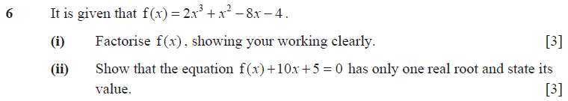  
  

  


Factor Remainder Theorem only



* 

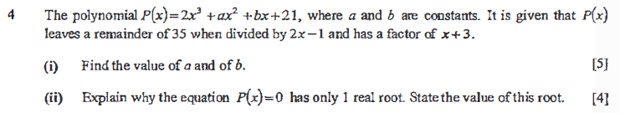  
,show quadratic portion determinant <0

Factor Remainder Theorem with substitution as extended question

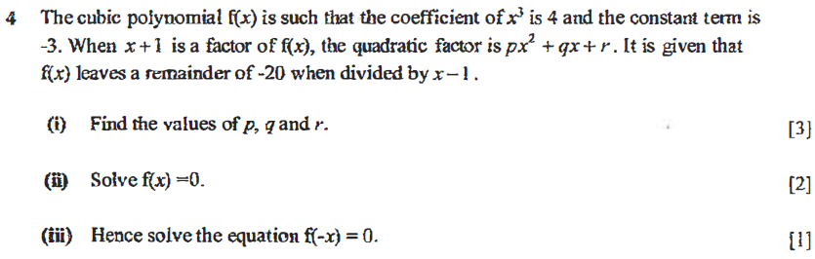  
    

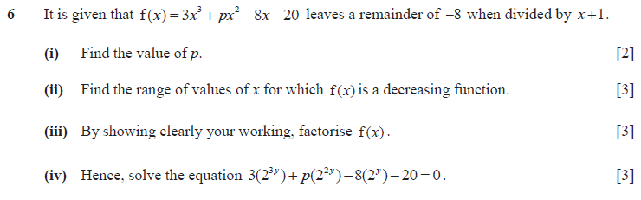



Need to form quotient remainder equation  
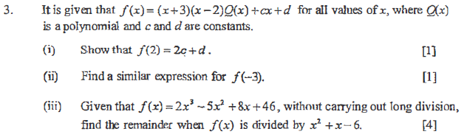  


Special question  
  
    

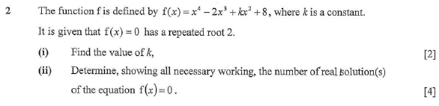  
 

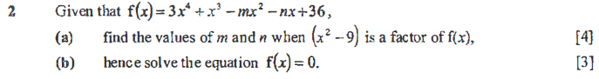  
m=31,  

Stopped at 483